The training of gamma in the RBF of Kc and

the Kc values for six gene pairs in Application 2
- Data in Application 1 and Application 2 have been standardized.

- Application 1:
  - TIAM1 vs. IL17A
The minimum of CV ($1.548 × {10}^{-9}$) is achieved by $γ=7.5$.
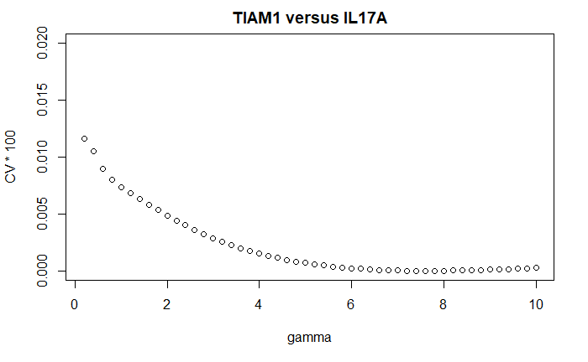

In the following, we show the training of gamma of the RBS kernel in Kc.

  - HST3 vs. RAD51
The minimum of $CV$ ($1.92 × {10}^{-8}$) is achieved by $γ=4.3$.
But, $CV=7.37×{10}^{-6}$ when$γ=1.0$; the difference between this CV and the min. is $<8 ×{10}^{-6} , so we used Kc-RBF with γ=1.0$.
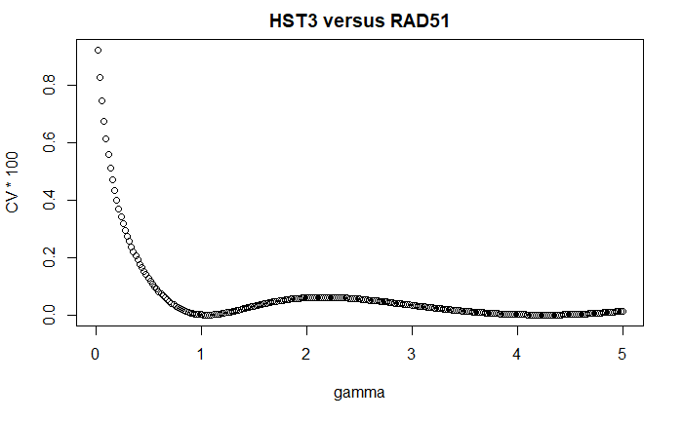

  - HST3 vs. RNR1
The minimum of $CV$ ($3.74 × {10}^{-8}$) is achieved by $γ=0.9$.
But $CV=7.16×{10}^{-5} when γ=1.0$; the difference between this CV and the min. is $<8 ×{10}^{-5}, so we used Kc-RBF with γ=1.0$.

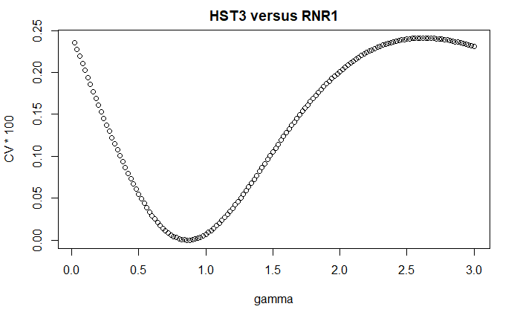

  - HST3 vs. SWE1
The minimum of $CV$($0.00603$) is achieved by $γ=0.7$.
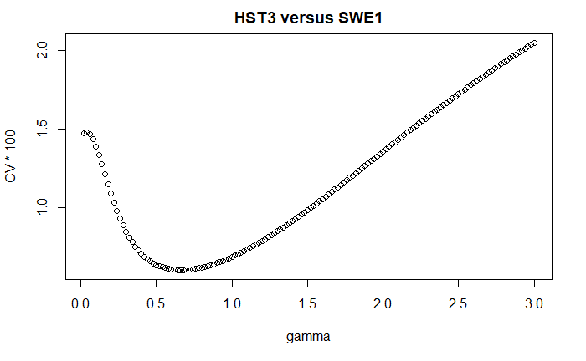

- Application 2: the results of Kernelized correlatin (Kc) and Pearson’s correlation
- For three gene pairs with similar patterns,
Kc-RBF with gamma = 0.5 computed by Repeat 1 and 2 data
Gene-pairs | Kc (Repeat1) | Kc (Repeat2) | mean | sd | p.value (t-test)
RNR1-SWE1 | 0.984 | 0.841 | 0.913 | 0.072 | 0.050
RNR1-RAD51 | 0.994 | 0.985 | 0.989 | 0.004 | 0.003
SWE1-RAD51 | 0.865 | 0.953 | 0.909 | 0.044 | 0.031

Pearson correlation results:
Gene-pairs | Pearson’s r (Repeat1) | Pearson’s r (Repeat2) | mean | sd | p.value  (t-test)
RNR1-SWE1 | 0.877 | 0.754 | 0.815 | 0.061 | 0.048
RNR1-RAD51 | 0.883 | 0.954 | 0.918 | 0.035 | 0.024
SWE1-RAD51 | 0.610 | 0.824 | 0.717 | 0.107 | 0.094

- For three anti-similar gene pairs

Kc with the trained gamma computed by Repeat 1 and 2 data
Gene-pairs | Kc (Rep1) | Kc (Rep2) | mean | sd | p.value (t-test)
HST3-RAD51  (RBF, $γ =1$) | -0.824 | -0.829 | -0.867 | 0.004 | 0.002
HST3-RNR1  ($RBF, γ =1$) | -0.861 | -0.844 | -0.853 | 0.012 | 0.006
HST3-SWE1  ($RBF, γ=0.7$) | -0.674 | -0.829 | -0.752 | 0.110 | 0.066

Pearson’s correlation results:
Gene-pairs | Pearson’s r (Rep1) | Pearson’s r (Rep2) | mean | sd | p.value (t-test)
HST3-RAD51 | -0.336 | -0.667 | -0.501 | 0.234 | 0.203
HST3-RNR1 | -0.434 | -0.659 | -0.546 | 0.159 | 0.129
HST3-SWE1 | -0.310 | -0.671 | -0.490 | 0.255 | 0.224

